**1. E.R. Model Concept**

* **Definition**: The Entity-Relationship (ER) model is a high-level data model that visually represents the data and their relationships in a database. It is primarily used in the conceptual design phase of database design.
* **Entities**: Objects or things in the real world that are distinguishable from others. Each entity has attributes that describe its properties.
  + **Example**: In a university database, entities can be "Student," "Course," and "Instructor."
* **Attributes**: Properties or characteristics of entities. Attributes can be:
  + **Simple**: Indivisible (e.g., Student ID)
  + **Composite**: Can be divided into smaller sub-parts (e.g., Full Name can be divided into First Name and Last Name)
  + **Derived**: Can be calculated from other attributes (e.g., Age can be derived from Date of Birth)
  + **Multi-valued**: Can have multiple values (e.g., Phone Numbers)
* **Relationships**: Associations between entities that illustrate how they interact with each other.
  + **Types**:
    - **One-to-One (1:1)**: Each instance of entity A is related to one instance of entity B and vice versa.
    - **One-to-Many (1**

**)**: Each instance of entity A can be related to multiple instances of entity B, but each instance of B is related to only one instance of A.

* + - **Many-to-Many (M**

**)**: Instances of both entities can be related to multiple instances of the other.

**2. Notation for ER Diagrams**

* **ER Diagrams**: Graphical representations of the ER model that use specific symbols to illustrate entities, attributes, and relationships.
* **Symbols**:
  + **Entity**: Represented by rectangles. For example, a rectangle labeled "Student."
  + **Attribute**: Represented by ovals. Attributes are connected to their respective entities with a line.
  + **Relationship**: Represented by diamonds. For example, a diamond labeled "Enrolls" connecting "Student" and "Course."
  + **Primary Key**: Underlined attribute within an entity, indicating its uniqueness (e.g., Student ID).
  + **Foreign Key**: An attribute in one entity that links to the primary key of another entity, often represented with dashed lines.
* **Example ER Diagram**:

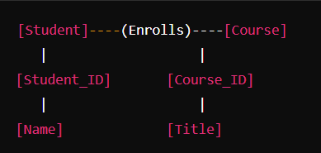

**3. Mapping Constraints**

Mapping constraints define the number of entities that can participate in a relationship. They help in ensuring data integrity and consistency.

* **Types of Mapping Constraints**:
  + **Cardinality Constraints**:
    - **One-to-One (1:1)**: A single instance of one entity is associated with a single instance of another entity.
    - **One-to-Many (1**

**)**: A single instance of one entity can be associated with multiple instances of another entity.

* + - **Many-to-Many (M**

**)**: Multiple instances of one entity can be associated with multiple instances of another entity.

* **Participation Constraints**:
  + **Total Participation**: Every instance of an entity must participate in at least one relationship (indicated by a double line).
  + **Partial Participation**: Some instances of an entity may not participate in a relationship (indicated by a single line).

**Summary**

* The ER model is essential for conceptual data modeling, providing a clear visual representation of entities, attributes, and relationships.
* Understanding the notations for ER diagrams helps in effectively designing and communicating database structures.
* Mapping constraints are crucial for defining how entities interact, ensuring data integrity, and establishing the rules governing those interactions.

**1. Aggregation**

* **Definition**: Aggregation is a concept in the ER model used to express a relationship between a relationship set and an entity set. It is useful when we need to treat a relationship as an entity itself.
* **Use Case**: Aggregation is often applied in scenarios where a relationship needs to have its own attributes or when the relationship connects to multiple entities.
* **Notation**: In ER diagrams, aggregation is represented by a dashed rectangle enclosing the relationship and the connected entities.

**Example**:

* + Consider an entity "Project" that is related to "Employee" and "Department" through a relationship "Works_On." If we want to represent a scenario where "Works_On" has an attribute like "Hours Worked," we can aggregate it.

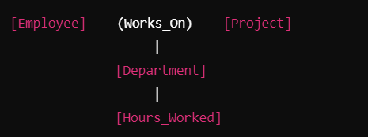

**2. Reducing ER Diagrams to Tables**

* **Process**: The process of converting an ER diagram into a relational schema involves the following steps:
  1. **Entities**: Each entity becomes a table. The attributes of the entity become the columns of the table. The primary key is determined from the entity's attributes.
  2. **Relationships**:
     + **One-to-One (1:1)**: Include the primary key of one entity as a foreign key in the other entity's table.
     + **One-to-Many (1**

**)**: Include the primary key of the "one" entity as a foreign key in the "many" entity's table.

* + - **Many-to-Many (M**

**)**: Create a new table for the relationship, including the primary keys of both entities as foreign keys in this new table.

* **Example**: Given the entities "Student" and "Course," and the relationship "Enrolls":

**ER Diagram**:

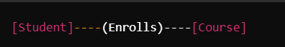

**Tables**:

* 1. **Student Table**:
     + Student_ID (Primary Key)
     + Name
  2. **Course Table**:
     + Course_ID (Primary Key)
     + Title
  3. **Enrolls Table** (for M

relationship):

* + - Student_ID (Foreign Key)
    - Course_ID (Foreign Key)

**3. Extended ER Model**

* **Definition**: The Extended ER (EER) model enhances the basic ER model by adding concepts like subclasses, superclasses, and categories. It allows for a more detailed representation of the data.
* **Key Concepts**:
  + **Superclasses and Subclasses**: A superclass is a generalization of one or more subclasses. Subclasses inherit attributes and relationships from the superclass.
    - **Example**: An entity "Vehicle" (superclass) can have subclasses "Car" and "Truck."
  + **Specialization**: The process of defining one or more subcategories of a superclass and forming a new entity from the existing entity.
  + **Generalization**: The process of defining a generalized entity from a set of specific entities.
  + **Category (Union Type)**: Represents a relationship between multiple entities. It allows instances of one entity to be treated as instances of another entity.
  + **Notation**: In EER diagrams, subclasses are represented using an ellipse connected to a rectangle (superclass), and the generalization/specialization relationship is typically indicated with a triangle.

**4. Relationships of Higher Degree**

* **Definition**: While typical relationships in the ER model are binary (involving two entities), relationships of higher degree involve three or more entities.
* **Example**: Consider a relationship "Works_On" that involves "Employee," "Project," and "Department." This relationship would indicate which employee works on which project in which department.
* **Representation**: In ER diagrams, a relationship of higher degree can be represented using a diamond shape connecting multiple entities.
* **Challenges**: Higher-degree relationships can complicate the design of the relational schema. Often, these relationships may need to be broken down into simpler binary relationships or require additional tables to fully capture the semantics.

**Summary**

* **Aggregation** is used to treat relationships as entities, enabling the inclusion of attributes on relationships.
* **Reducing ER diagrams to tables** involves systematically converting entities and relationships into relational schemas.
* The **Extended ER model** provides additional features like subclassing and categorization for more complex data representations.
* **Relationships of higher degree** allow for interactions among three or more entities but may complicate the design of the database schema.

**1. Functional Dependencies**

* **Definition**: A functional dependency (FD) is a constraint between two sets of attributes in a relation from a database. It states that the value of one attribute (or a group of attributes) determines the value of another attribute.
* **Notation**: If A and B are attributes (or sets of attributes), then A→B means that for each value of A, there is exactly one value of B.

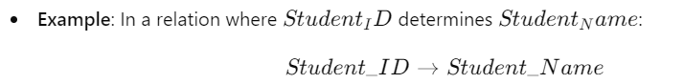**Importance**: Understanding functional dependencies is essential for identifying the structure of a relation and for normalization, which helps eliminate redundancy and anomalies.

**2. Normal Forms**

Normal forms are guidelines for designing relations to reduce redundancy and improve data integrity. Each normal form addresses specific types of anomalies.

**2.1. First Normal Form (1NF)**

* **Definition**: A relation is in 1NF if all its attributes contain atomic values (indivisible). There should be no repeating groups or arrays.
* **Requirements**:
  + Each column must contain unique values.
  + Each row must be unique.
  + Each cell must contain a single value (no lists or sets).
* **Example**:

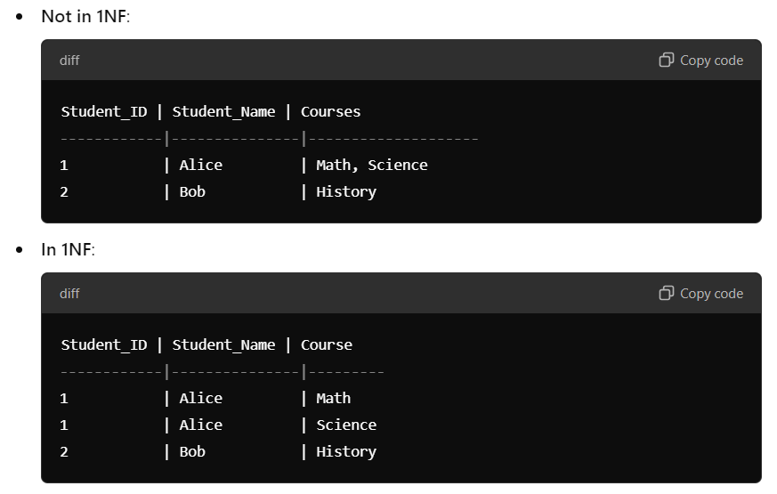

**2.2. Second Normal Form (2NF)**

* **Definition**: A relation is in 2NF if it is in 1NF and all non-key attributes are fully functionally dependent on the primary key. This means that non-key attributes cannot depend on a part of a composite primary key.
* **Requirements**:
  + Eliminate partial dependencies (where a non-key attribute is dependent on part of a composite key).
* 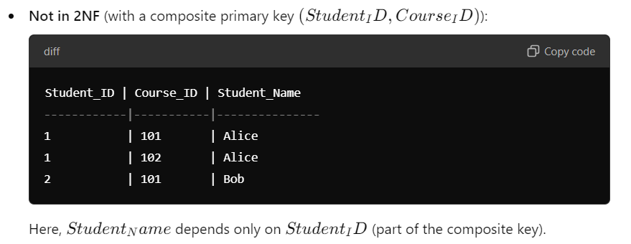**Example**:

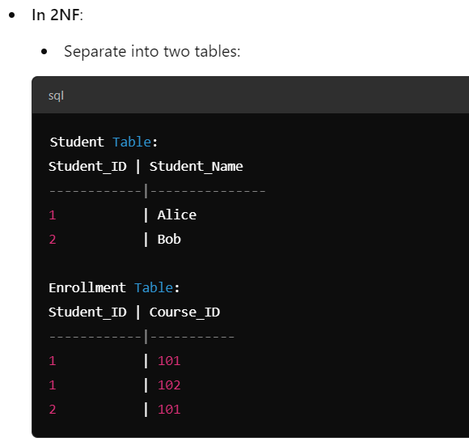

**2.3. Third Normal Form (3NF)**

* **Definition**: A relation is in 3NF if it is in 2NF and no transitive dependencies exist. A transitive dependency occurs when a non-key attribute depends on another non-key attribute.
* **Requirements**:
  + Eliminate transitive dependencies.
* **Example**: 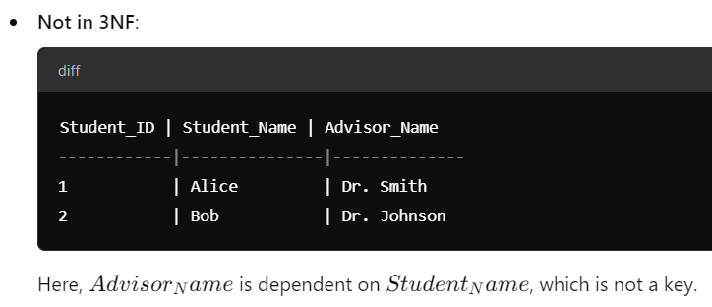

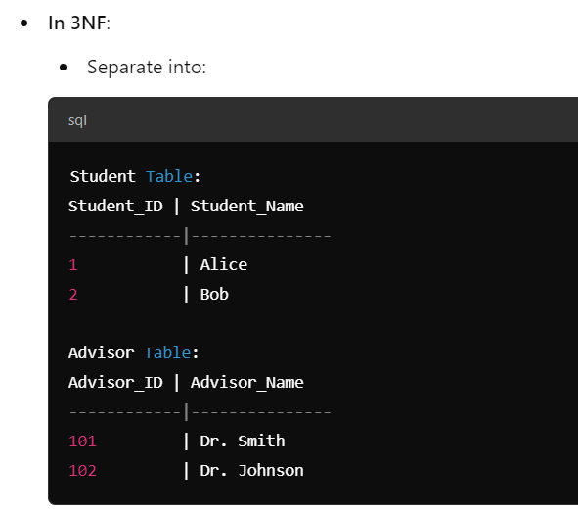

**3. Boyce-Codd Normal Form (BCNF)**

* **Definition**: A relation is in BCNF if it is in 3NF and every functional dependency X→Y, X is a superkey. This means there should be no dependencies where a non-superkey determines another attribute.
* **Importance**: BCNF handles anomalies that 3NF may not resolve, particularly in cases with overlapping candidate keys.
* **Example**: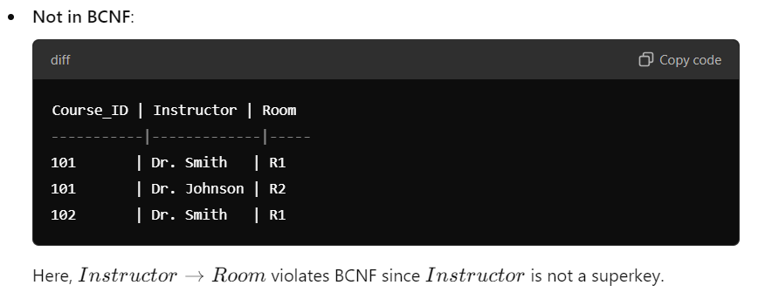

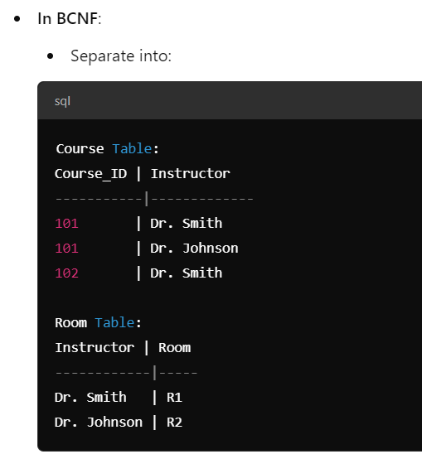

**Summary**

* **Functional dependencies** are essential for understanding the relationships between attributes in a database.
* **Normal forms** help eliminate redundancy and maintain data integrity by establishing rules for structuring relations.
* **1NF**, **2NF**, and **3NF** progressively eliminate different types of redundancy and dependency issues.
* **BCNF** is a stricter version of 3NF that addresses additional anomalies.

**Multi-Valued Dependencies (MVD)**

* **Definition**: A multi-valued dependency occurs when one attribute in a relation determines another attribute, but the second attribute can have multiple independent values for each value of the first attribute.
* **Notation**: If A is a set of attributes and B is another set of attributes, then the notation A↠B means that for a given value of A, there can be multiple values of B.
* **Importance**: MVDs can lead to redundancy and anomalies in data. Handling them properly is essential for designing a normalized database.
* **Example**:

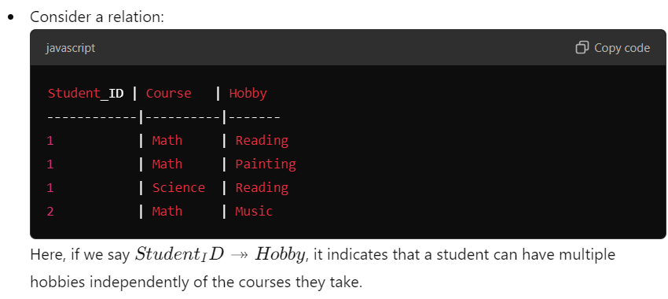**3. Fourth Normal Form (4NF)**

* **Definition**: A relation is in Fourth Normal Form (4NF) if it is in Boyce-Codd Normal Form (BCNF) and has no multi-valued dependencies.
* **Importance**: 4NF removes redundancy caused by MVDs. It ensures that if a relation contains a multi-valued dependency, it should be split into separate relations.
* 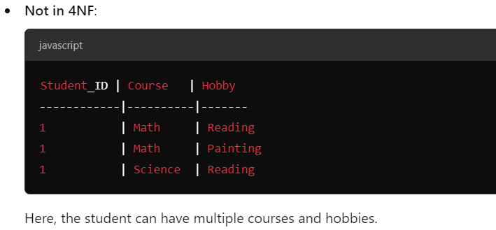**Example**:

**In 4NF**:

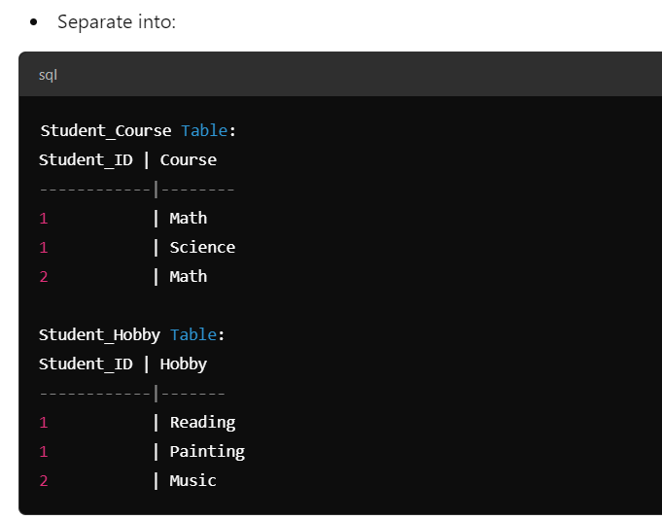

**4. Join Dependencies (JD)**

* **Definition**: A join dependency occurs when a relation can be reconstructed by joining multiple smaller relations. It is expressed as R→{S1,S2,…,Sn} meaning that relation R can be recreated by joining relations S1,S2,…,Sn​.
* **Importance**: Join dependencies are important in defining Fifth Normal Form (5NF). They help in eliminating redundancy caused by the presence of multiple relations that are not adequately represented.

**5. Fifth Normal Form (5NF)**

* **Definition**: A relation is in Fifth Normal Form (5NF) if it is in 4NF and has no join dependencies except that which is implied by the candidate keys. This means that any join dependencies present must be a result of the natural relationships between attributes.
* **Importance**: 5NF ensures that the database design is free from redundancy due to join dependencies. It allows for a clean and efficient representation of data without unnecessary complexity.
* 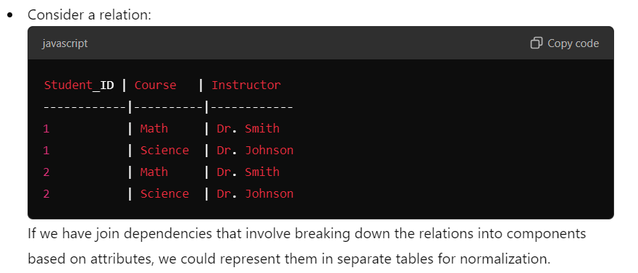**Example**:

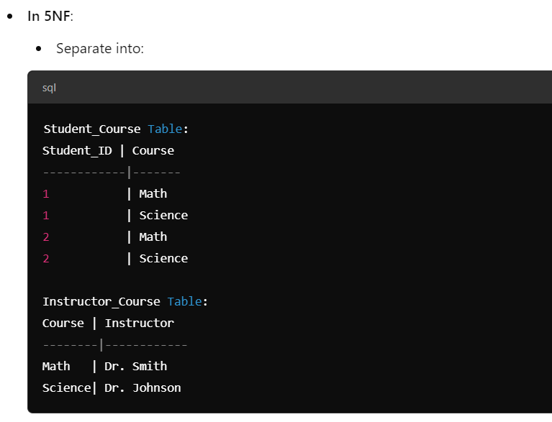**Summary**

* **BCNF** ensures that all functional dependencies have superkeys as determinants, removing anomalies.
* **Multi-Valued Dependencies (MVDs)** can lead to redundancy; thus, 4NF addresses them by separating related data.
* **Join Dependencies** help reconstruct relations, which is vital for defining 5NF.
* **5NF** eliminates redundancy arising from join dependencies, ensuring a streamlined database design.

**1. Inclusion Dependencies**

* **Definition**: An inclusion dependency specifies a relationship between two relations (or tables) where a set of values in one relation must also exist in another relation. It is expressed as R1[A]⊆R2[B], meaning that for every value of attribute A in relation R1, there exists a corresponding value of attribute B in relation R2​.
* **Notation**: If R1​ is a relation with attribute set A and R2 is a relation with attribute set B, the inclusion dependency is written as:

R1[A]⊆R2[B]

* **Importance**: Inclusion dependencies are used to enforce referential integrity between tables. They ensure that relationships between entities are maintained, preventing orphan records.
* **Example**:
  + Consider two relations:

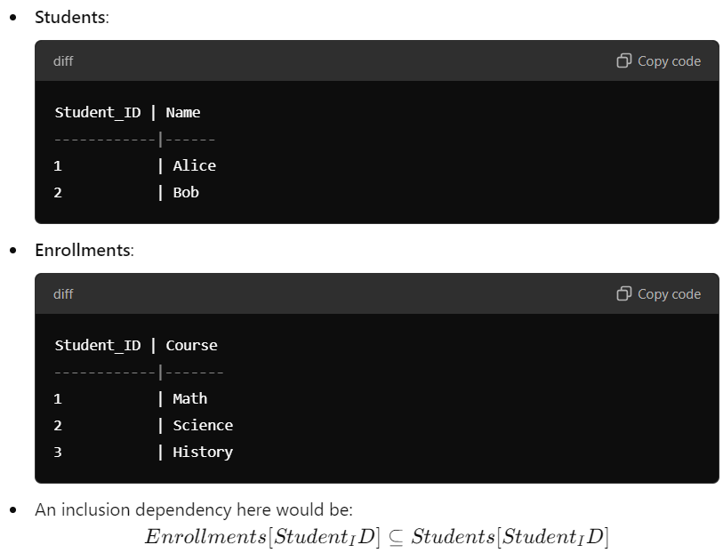This means that every Student_ID in the Enrollments relation must exist in the Students relation.

**2. Lossless Join Decompositions**

* **Definition**: A decomposition of a relation is considered lossless if, after decomposing the relation into two or more sub-relations, we can join them back together to obtain the original relation without losing any information.
* **Importance**: Lossless join decompositions are crucial in normalization, as they prevent the loss of data integrity during the process of dividing relations to eliminate redundancy.
* **Conditions for Lossless Join**:
  + The decomposition R into R1​ and R2 is lossless if at least one of the following conditions holds:
    1. The common attributes R1∩R2​ form a superkey for either R1 or R2​.
    2. If R1​ and R2​ are derived from a functional dependency X→Y such that X is a superkey for the relation.
* **Example**:

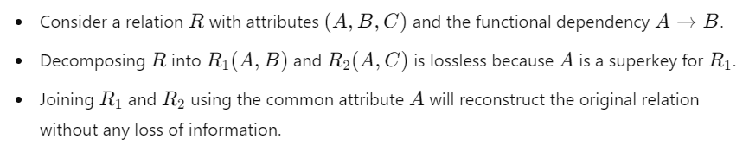**3. Normalization Using Functional Dependencies (FD)**

* **Process**: Normalization using functional dependencies involves analyzing the relations to eliminate redundancy and ensure that the database is structured according to normal forms (1NF, 2NF, 3NF, BCNF).
* **Steps**:
  1. **Identify Functional Dependencies**: Determine all functional dependencies present in the relation.
  2. **Check Normal Form**: Assess the current normal form of the relation based on the identified functional dependencies.
  3. **Decompose as Necessary**: If the relation violates any normal form, decompose it into smaller relations that adhere to the appropriate normal form.
* 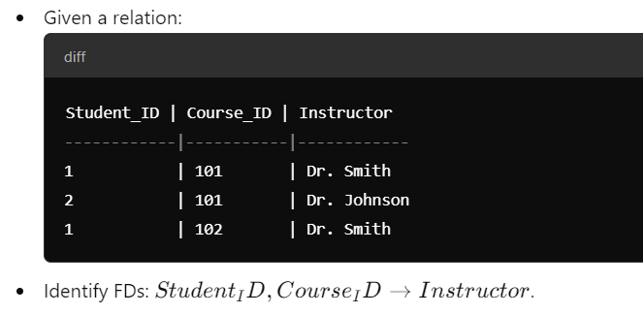**Example**:
  1. Check for violations:
     + The relation is not in BCNF since Instructor is not dependent on a superkey.

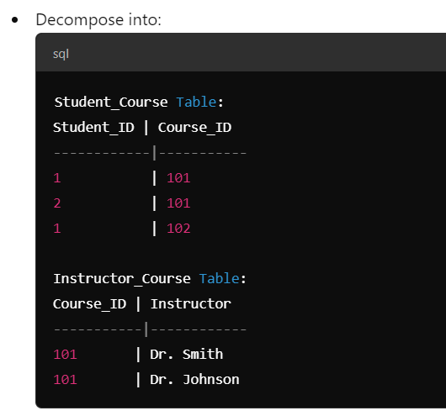

**4. Normalization Using Multi-Valued Dependencies (MVD)**

* **Process**: Normalization using multi-valued dependencies helps eliminate redundancy caused by the presence of attributes that can have multiple independent values.
* **Steps**:
  1. **Identify Multi-Valued Dependencies**: Determine all multi-valued dependencies present in the relation.
  2. **Check for 4NF Violations**: If the relation contains MVDs, it may violate 4NF.
  3. **Decompose as Necessary**: Separate the relation into multiple relations that adhere to 4NF.
* **Example**:
  1. 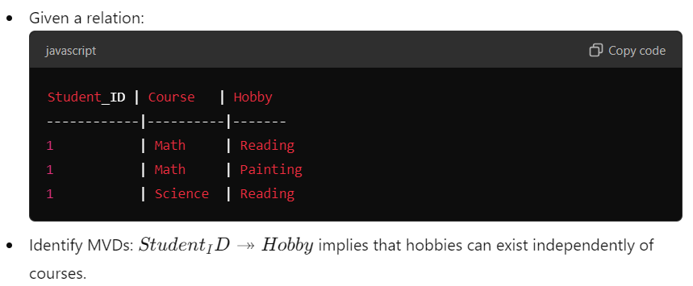Check for 4NF violations:
     + Since MVDs are present, this relation is not in 4NF.

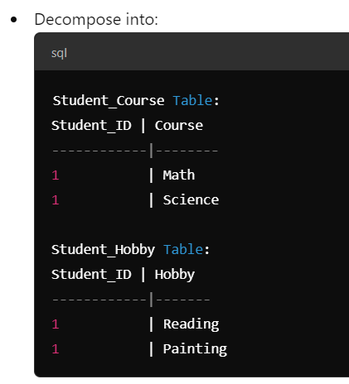

**Summary**

* **Inclusion dependencies** enforce referential integrity between relations, ensuring related data remains consistent.
* **Lossless join decompositions** prevent data loss during the normalization process, allowing the original relation to be reconstructed.
* **Normalization using functional dependencies** focuses on eliminating redundancy and achieving the appropriate normal form.
* **Normalization using multi-valued dependencies** ensures that independent multi-valued attributes are handled appropriately, leading to a more efficient database structure.

**1. Transaction Processing Concepts**

**1.1. Transaction Processing System (TPS)**

* **Definition**: A Transaction Processing System is a software system that facilitates and manages the processing of transactions. It ensures that all parts of a transaction are executed correctly and provides mechanisms for ensuring data integrity.
* **Characteristics**:
  + **High Availability**: TPS must be operational 24/7.
  + **Scalability**: Ability to handle increasing amounts of transactions.
  + **Concurrency**: Multiple transactions can occur simultaneously without interference.
  + **Reliability**: Ensures data integrity and correctness.

**1.2. ACID Properties**

ACID properties ensure reliable processing of database transactions:

* **Atomicity**: A transaction is treated as a single unit. If any part of the transaction fails, the entire transaction is rolled back.
* **Consistency**: Transactions must leave the database in a consistent state. All integrity constraints must be maintained.
* **Isolation**: Transactions are executed independently of one another. The intermediate state of a transaction is invisible to others.
* **Durability**: Once a transaction has been committed, it remains permanent, even in the event of a system failure.

**2. Schedule and Recoverability**

* **Schedule**: A sequence of operations from a set of transactions, which indicates the order of execution of the transactions.

**3. Testing of Serializability**

* **Serializability**: A schedule is serializable if its outcome is equivalent to a schedule where transactions are executed serially, one after another, without overlapping.
* **Types**:
  + **Conflict Serializability**: A schedule is conflict serializable if it can be transformed into a serial schedule by swapping non-conflicting operations.
  + **View Serializability**: A schedule is view serializable if it produces the same result as some serial schedule in terms of the final values read by transactions.

**3.1. Conflict and View Serializability**

* **Conflict**: Two operations are conflicting if they belong to different transactions and at least one of them is a write operation on the same data item.
* **View**: Two schedules are considered to be view equivalent if:
  + They read the same initial values.
  + They read the same values written by transactions.

**4. Serializable Schedule**

* **Definition**: A schedule is serializable if its result is the same as the result of some serial schedule of those transactions.
* **Importance**: Serializability ensures consistency in databases by preventing phenomena such as dirty reads, lost updates, and uncommitted data from interfering with transaction outcomes.

**5. Transaction Processing in Distributed Databases**

* **Distributed Databases**: Databases spread across multiple locations (servers) that communicate and synchronize with one another.
* **Challenges**:
  + **Latency**: Delays in communication between distributed nodes can affect transaction processing time.
  + **Consistency**: Maintaining ACID properties across multiple nodes is more complex.
  + **Failure Recovery**: Dealing with failures in one part of the distributed system while ensuring overall integrity.

**5.1. Fragmentation**

* **Definition**: The process of dividing a database into smaller, more manageable pieces called fragments.
* **Types**:
  + **Horizontal Fragmentation**: Rows are divided into different fragments.
  + **Vertical Fragmentation**: Columns are divided into different fragments.
  + **Mixed Fragmentation**: A combination of both horizontal and vertical fragmentation.

**6. Locking**

* **Locking Mechanisms**: Used to manage access to data by multiple transactions to ensure isolation.
* **Types**:
  + **Exclusive Lock**: A transaction has sole access to the data; no other transaction can read or write.
  + **Shared Lock**: Multiple transactions can read the data, but no transaction can write to it.

**7. Protocols for Distributed Databases**

* **Two-Phase Commit Protocol (2PC)**:
  + **Phase 1**: Prepare Phase - The coordinator asks all participants to prepare for the commit.
  + **Phase 2**: Commit Phase - If all participants are ready, the coordinator commits; otherwise, it aborts.
* **Three-Phase Commit Protocol (3PC)**: An extension of 2PC that introduces an additional phase to reduce the chances of blocking.

**8. Recovery from Transaction Failures**

* **Techniques**:
  + **Log-Based Recovery**: Maintaining a log of all transactions allows the system to restore the database to a consistent state by replaying or undoing transactions.
  + **Checkpointing**: Periodically saving the state of the database to enable faster recovery after a failure.

**9. Deadlock Handling**

* **Definition**: A deadlock occurs when two or more transactions are waiting indefinitely for resources held by each other.
* **Methods**:
  + **Deadlock Prevention**: Strategies to ensure that the system never enters a deadlock state (e.g., resource ordering).
  + **Deadlock Detection**: Periodically checking for deadlocks in the system and aborting one or more transactions to resolve the deadlock.
  + **Deadlock Recovery**: Terminating one or more transactions to break the cycle of dependency.

**Summary**

* **Transaction Processing Systems (TPS)** manage and ensure reliable processing of transactions.
* **ACID properties** guarantee data integrity and consistency during transaction execution.
* **Schedules** determine the order of transactions, and their **recoverability** is crucial for maintaining consistency.
* **Serializability** ensures that concurrent transaction schedules yield the same results as some serial execution.
* **Distributed databases** introduce additional challenges like fragmentation, locking, and maintaining ACID properties across multiple locations.
* **Recovery mechanisms** and **deadlock handling** strategies are vital for ensuring the reliability of transactions.

**1. Concurrency Control Techniques**

Concurrency control is essential in database management systems to ensure that transactions are executed in a way that maintains data integrity and consistency. The primary methods for concurrency control include locking techniques, timestamp protocols, and techniques specific to distributed systems.

**1.1. Locking Techniques for Concurrency Control**

Locking mechanisms are used to manage access to data by concurrent transactions. There are several types of locks and protocols for using them.

* **Types of Locks**:
  + **Exclusive Lock (X-Lock)**: Allows the transaction to both read and write the data. No other transaction can read or write until the lock is released.
  + **Shared Lock (S-Lock)**: Allows multiple transactions to read the data but not to write. Other transactions can obtain shared locks but cannot obtain exclusive locks until all shared locks are released.
* **Locking Protocols**:
  + **Two-Phase Locking (2PL)**:
    - **Growing Phase**: A transaction can acquire locks but cannot release any.
    - **Shrinking Phase**: A transaction can release locks but cannot acquire any new ones.
    - **Strict 2PL**: Requires that all locks be held until the transaction commits, ensuring serializability.
    - **Rigorous 2PL**: A stricter version where all locks are held until the end of the transaction.
* **Deadlock in Locking**: A situation where two or more transactions wait indefinitely for locks held by each other. Deadlock detection and resolution techniques must be employed to handle this scenario.

**1.2. Timestamp Protocols for Concurrency Control**

Timestamp protocols assign a unique timestamp to each transaction, which determines the order of transaction execution.

* **Basic Concepts**:
  + Each transaction Ti​ is assigned a timestamp TS(Ti).
  + Transactions are executed in the order of their timestamps.
* **Types of Timestamp Protocols**:
  + **Wait-Die Scheme**:
    - If an older transaction requests a lock held by a younger transaction, the older transaction waits.
    - If a younger transaction requests a lock held by an older transaction, the younger transaction is aborted (dies).
  + **Wound-Wait Scheme**:
    - If an older transaction requests a lock held by a younger transaction, the younger transaction is aborted (wounded).
    - If a younger transaction requests a lock held by an older transaction, it waits.
* **Timestamp Ordering Protocol**: Ensures that conflicting operations of transactions are executed in timestamp order. If a conflict occurs (e.g., two transactions trying to write to the same data), one transaction may be rolled back or aborted based on its timestamp.

**1.3. Concurrency Control in Distributed Systems**

Concurrency control in distributed databases presents unique challenges due to the decentralized nature of the system.

* **Challenges**:
  + **Network Latency**: Communication delays can lead to inconsistencies.
  + **Replica Synchronization**: Ensuring that all copies of the data remain consistent across distributed nodes.
  + **Failure Recovery**: Handling transaction failures while maintaining data integrity.
* **Techniques**:
  + **Distributed Locking**: Uses locks similar to centralized systems but ensures that they are managed across multiple nodes.
    - **Centralized Lock Manager**: A single node manages locks for all transactions, which can create a bottleneck.
    - **Distributed Lock Management**: Locks are managed across nodes to avoid single points of failure and bottlenecks.
  + **Optimistic Concurrency Control**: Transactions execute without locking but validate before committing.
    - **Phases**:
      * **Read Phase**: Read data and perform computations.
      * **Validation Phase**: Check if data was modified by other transactions during the read phase.
      * **Write Phase**: If validation passes, write changes; otherwise, abort.
  + **Two-Phase Commit Protocol (2PC)**: Ensures that all nodes in a distributed system either commit or roll back a transaction. The protocol consists of:
    - **Prepare Phase**: The coordinator asks all participants to prepare for the commit.
    - **Commit Phase**: If all participants are ready, the coordinator commits; otherwise, it aborts.
  + **Three-Phase Commit Protocol (3PC)**: An enhancement of 2PC that adds an additional phase to reduce blocking scenarios and improve fault tolerance.

**Summary**

* **Locking Techniques** involve the use of exclusive and shared locks, and Two-Phase Locking (2PL) ensures that transactions are executed serially.
* **Timestamp Protocols** utilize transaction timestamps to order operations and manage conflicts, with schemes like Wait-Die and Wound-Wait for handling locks.
* **Concurrency Control in Distributed Systems** requires distributed locking mechanisms, optimistic concurrency control, and commit protocols (2PC and 3PC) to manage transactions across multiple nodes effectively.

**1. Recovery System**

A recovery system is crucial in database management systems (DBMS) to ensure data integrity and availability in the event of failures. It provides mechanisms to recover from various types of failures.

**1.1. Failure Classification**

Failures can be classified into different categories based on their nature and impact on the database system:

* **Transaction Failures**: Occur when a transaction cannot complete due to reasons like application errors, deadlocks, or resource unavailability.
* **System Failures**: Result from hardware or software malfunctions, such as crashes, power outages, or software bugs.
* **Media Failures**: Involve physical damage to storage media (e.g., hard disk failure) that affects data accessibility.
* **Logical Failures**: Occur when data integrity is compromised due to issues like inconsistent data or violations of integrity constraints.

**1.2. Log-Based Recovery**

Log-based recovery uses a transaction log to track changes made to the database. This log records all transactions and their operations, which helps in recovering the database to a consistent state.

* **Log Structure**:
  + Each entry in the log typically contains:
    - Transaction ID
    - Operation (e.g., READ, WRITE)
    - Data item affected
    - Old value (before the operation)
    - New value (after the operation)
  + Log entries are written in a sequential manner to ensure a complete record of all operations.
* **Recovery Process**:
  + **Undo Phase**: Roll back any transactions that were active at the time of the failure. This involves reading the log backward and restoring the old values of modified data items.
  + **Redo Phase**: Reapply all committed transactions that were recorded in the log after the last checkpoint to ensure that all changes are reflected in the database.
* **Checkpointing**: Periodic snapshots of the database state that allow faster recovery. A checkpoint records the state of the database and the transactions that were committed at that point. If a failure occurs, recovery can start from the last checkpoint instead of the beginning of the log.

**1.3. Shadow Paging**

Shadow paging is an alternative recovery technique that maintains two page tables: the current page table and a shadow page table.

* **Mechanism**:
  + **Current Page Table**: Points to the current version of the data pages.
  + **Shadow Page Table**: Points to the previous stable version of the data pages.
  + When a transaction modifies a page, the changes are made in a new page rather than overwriting the existing page. The page table is updated to point to the new page only after the transaction commits.
* **Recovery Process**:
  + In the event of a failure, the system can revert to the shadow page table, effectively discarding any uncommitted changes made by transactions since the last commit.
* **Advantages**:
  + No need for log writing or undo/redo operations, making it a simpler recovery mechanism.
  + Efficient in scenarios where read operations dominate, as it allows for faster access to stable data.

**1.4. Buffer Management**

Buffer management deals with the temporary storage of data in memory (buffer) to optimize database performance.

* **Buffer Pool**: A memory area that holds pages read from the disk. The buffer pool is crucial for minimizing disk I/O operations, as accessing data in memory is faster than reading it from disk.
* **Buffer Replacement Policies**:
  + **Least Recently Used (LRU)**: Evicts the least recently used pages from the buffer pool when new pages need to be loaded.
  + **First-In-First-Out (FIFO)**: Evicts pages in the order they were added to the buffer.
  + **Clock Algorithm**: A more efficient approximation of LRU that maintains a circular list of pages with a reference bit.
* **Write Policies**:
  + **Write-Through**: Every write operation is immediately written to disk as well as to the buffer.
  + **Write-Back**: Changes are written to the buffer and written to disk at a later time, reducing disk I/O but requiring careful management to ensure data integrity.

**Summary**

* **Failure Classification** includes transaction, system, media, and logical failures, each requiring specific recovery strategies.
* **Log-Based Recovery** leverages a transaction log to roll back or redo operations, with checkpoints to enhance recovery speed.
* **Shadow Paging** employs a dual-page table mechanism to simplify recovery by maintaining a stable version of the database.
* **Buffer Management** optimizes data access through the use of a buffer pool and employs various replacement and write policies to enhance performance.

**1. Distributed Database**

A distributed database is a collection of data that is stored across multiple locations (nodes) and managed by a distributed database management system (DDBMS). The key features include transparency, scalability, and fault tolerance.

**1.1. Basic Concepts**

* **Transparency**: Users should be unaware of the physical distribution of data. This includes:
  + **Location Transparency**: Users can access data without knowing its location.
  + **Replication Transparency**: Users do not need to be aware of multiple copies of data.
  + **Failure Transparency**: The system should recover from failures without affecting users.
* **Distributed Database Management System (DDBMS)**: A software system that manages distributed databases, ensuring data consistency, integrity, and availability.
* **Types of Distributed Databases**:
  + **Homogeneous Distributed Databases**: All nodes use the same DBMS and are similar in architecture.
  + **Heterogeneous Distributed Databases**: Nodes may use different DBMSs, architectures, and may not be compatible with each other.

**2. Fragmentation**

Fragmentation is the process of dividing a database into smaller, manageable pieces called fragments. This approach improves performance and scalability.

* **Types of Fragmentation**:
  + **Horizontal Fragmentation**: Rows of a table are divided into different fragments based on a certain condition (e.g., geographical location).
    - Example: A customer database can be fragmented into different tables based on regions (e.g., North America, Europe).
  + **Vertical Fragmentation**: Columns of a table are divided into different fragments. Each fragment contains a subset of the attributes.
    - Example: A customer table can be fragmented into two fragments, one containing personal information (name, address) and the other containing transactional data (purchase history).
  + **Mixed Fragmentation**: Combines horizontal and vertical fragmentation, allowing for a more flexible structure.
* **Benefits of Fragmentation**:
  + **Improved Performance**: Reduces the amount of data transferred over the network by fetching only relevant fragments.
  + **Scalability**: Fragments can be distributed across nodes to balance load and optimize resource usage.

**3. Distributed Database Design**

Designing a distributed database involves careful consideration of data distribution, fragmentation, and replication strategies to optimize performance and reliability.

* **Key Design Principles**:
  + **Data Distribution**: Decide how to distribute data across different nodes (fragmentation).
  + **Replication Strategy**: Determine how to maintain copies of data for fault tolerance and high availability.
    - **Full Replication**: Every site stores a complete copy of the database.
    - **Partial Replication**: Only certain fragments are replicated at specific sites.
* **Considerations for Design**:
  + **Access Patterns**: Analyze how data will be accessed to optimize fragmentation and replication strategies.
  + **Network Latency**: Minimize communication costs between nodes by strategically placing data.
  + **Fault Tolerance**: Ensure data availability even in case of node failures through appropriate replication.

**4. Distributed Transaction Management**

Distributed transaction management ensures that transactions across multiple nodes are executed in a manner that maintains consistency and integrity.

* **ACID Properties in Distributed Systems**:
  + **Atomicity**: All operations in a transaction must either complete successfully or be rolled back.
  + **Consistency**: The database must remain in a consistent state before and after the transaction.
  + **Isolation**: Transactions should be isolated from each other to avoid interference.
  + **Durability**: Once a transaction is committed, its effects are permanent.

**4.1. Two-Phase Commit Protocol (2PC)**

A widely used protocol to ensure atomicity in distributed transactions.

* **Phases**:
  + **Prepare Phase**: The coordinator sends a prepare message to all participants. Each participant votes on whether it can commit.
  + **Commit Phase**: If all participants vote "yes," the coordinator sends a commit message; otherwise, it sends an abort message.
* **Limitations**: 2PC can lead to blocking if the coordinator fails after the prepare phase and before the commit phase.

**5. Concurrency Control in Distributed Databases**

Concurrency control ensures that simultaneous transactions do not lead to inconsistencies in the database.

* **Locking Mechanisms**:
  + Distributed locking techniques are employed to manage access to data across nodes, similar to centralized systems.
* **Optimistic Concurrency Control**:
  + Allows transactions to execute without acquiring locks, validating them at the time of commit.

**5.1. Timestamp-Based Concurrency Control**

* **Mechanism**: Each transaction is assigned a unique timestamp that determines its serialization order.
* **Types of Timestamp Protocols**:
  + **Wait-Die Scheme**: Older transactions can wait for younger ones, while younger ones are aborted if they request a lock held by older transactions.
  + **Wound-Wait Scheme**: Younger transactions are aborted if they request a lock held by older transactions.

**6. Timestamps**

Timestamps are used in distributed databases to maintain the order of transactions and manage concurrency.

* **Logical Timestamps**: A unique timestamp is assigned to each transaction at its start.
* **Physical Timestamps**: Based on actual time, these timestamps can help order transactions in real-time scenarios.
* **Timestamp Ordering Protocol**:
  + Ensures that conflicting operations are executed in the order of their timestamps, helping maintain consistency and isolation in a distributed environment.

**Summary**

* **Distributed Databases** offer transparency, scalability, and fault tolerance, managing data across multiple locations.
* **Fragmentation** optimizes performance and scalability by dividing data into horizontal, vertical, or mixed fragments.
* **Distributed Database Design** focuses on data distribution and replication strategies to enhance access and reliability.
* **Distributed Transaction Management** employs protocols like 2PC to maintain ACID properties across multiple nodes.
* **Concurrency Control** techniques, including locking and timestamp protocols, ensure data consistency in the face of simultaneous transactions.

**1. Distributed Query Management**

Distributed query management involves optimizing and executing queries across a distributed database system. The main challenges include translating global queries into fragment queries and managing data distribution efficiently.

**1.1. Translation of Global Queries to Fragment Queries**

Global queries are those that access data from multiple fragments or locations in a distributed database. The goal is to translate these global queries into smaller, localized fragment queries that can be executed at the respective nodes.

* **Steps in Translation**:
  1. **Query Parsing**: The global query is analyzed to determine its structure and components.
  2. **Query Decomposition**: The global query is decomposed into smaller subqueries that target specific fragments. This involves:
     + Identifying the relevant fragments for each part of the global query.
     + Creating subqueries that only access the necessary data from those fragments.
  3. **Optimization**: The system optimizes the subqueries for execution based on data distribution, network costs, and available resources.
* **Example**: Consider a global query to retrieve all customer orders from different regions:
  1. Global Query: SELECT * FROM Orders WHERE Region = 'North America'
  2. Translated Fragment Queries:
     + SELECT * FROM Orders_NA (accessing the North America fragment)
     + Additional fragment queries for other regions if needed.

**2. Join Queries**

Join queries in a distributed database involve combining data from different fragments based on a common attribute.

**2.1. Types of Join Queries:**

* **Local Joins**: Joins between data that resides in the same fragment.
* **Global Joins**: Joins that require data from multiple fragments.

**2.2. Handling Join Queries:**

* **Join Strategies**:
  + **Ship and Join**: One fragment sends its data to another fragment for joining.
  + **Join and Ship**: Data from the joined fragments is processed locally, and only the results are sent back.
* **Example**: Joining customer data with order data across different fragments:
  + 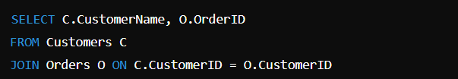**Global Join Query**:

**Translation**:

* + - Query fragments from the Customers fragment and the Orders fragment separately, and then perform the join operation.

**3. Semi-Join Queries**

A semi-join is a specific type of join that retrieves matching rows from one relation based on the existence of matching rows in another relation. Unlike regular joins, semi-joins do not return all columns from both tables, only those from one table.

**3.1. Characteristics of Semi-Join:**

* **Reduced Data Transfer**: Semi-joins minimize the amount of data sent across the network, improving performance.
* **Definition**: For relations A and B, a semi-join of A with B returns all rows from A for which there are matching rows in B.

**3.2. Execution of Semi-Joins:**

* **Two-Step Process**:
  1. **Send a Query to the Fragment with the Smaller Dataset**: Retrieve the keys or identifiers that match the join condition.
  2. **Retrieve Data from the Other Fragment**: Fetch the relevant rows from the other fragment using the identifiers obtained.
* **Example**: Consider a scenario where you want to find customers who have placed orders:
  1. 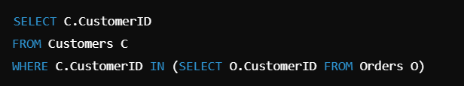**Semi-Join Query**:

**Execution Steps**:

* + 1. First, retrieve the unique CustomerID values from the Orders fragment.
    2. Then, use these IDs to fetch the relevant customer details from the Customers fragment.

**Summary**

* **Distributed Query Management** involves translating global queries into localized fragment queries to optimize data access across nodes.
* **Join Queries** combine data from multiple fragments and can use various strategies for execution based on data distribution.
* **Semi-Join Queries** focus on retrieving relevant rows from one relation based on matches in another, reducing data transfer costs and improving performance.

**1. Distributed Transaction**

A distributed transaction is a transaction that accesses and modifies data stored across multiple locations or nodes in a distributed database system. Managing these transactions is critical to ensuring data consistency and integrity.

**1.1. Characteristics of Distributed Transactions**

* **Atomicity**: The transaction must either complete entirely or not at all, even if it involves multiple nodes.
* **Consistency**: All nodes must maintain a consistent state before and after the transaction.
* **Isolation**: Transactions must operate independently to prevent interference.
* **Durability**: Once a transaction is committed, its effects must persist despite failures.

**2. Recovery of Distributed Transactions**

Recovery mechanisms are essential for handling failures that may occur during distributed transactions.

**2.1. Logging and Recovery Strategies**

* **Transaction Logs**: Distributed systems maintain logs at each node to record the operations performed by transactions. These logs include:
  + Transaction IDs
  + Operations performed
  + Timestamps
  + Previous states of modified data
* **Recovery Process**:
  + **Undo Phase**: Roll back transactions that were active at the time of failure, using the logs to restore data to its previous state.
  + **Redo Phase**: Reapply changes made by committed transactions after the last checkpoint.
* **Global Recovery**: Coordinated recovery across all nodes involved in a distributed transaction to ensure consistency.

**3. Two-Phase Commit Protocol (2PC)**

The two-phase commit protocol is a distributed algorithm that ensures all participating nodes in a distributed transaction either commit or abort the transaction.

**3.1. Phases of 2PC**

* **Phase 1: Prepare Phase**:
  + The coordinator sends a "prepare" message to all participant nodes, asking them to prepare to commit.
  + Each participant responds with either a "yes" (can commit) or "no" (cannot commit).
* **Phase 2: Commit Phase**:
  + If all participants respond with "yes," the coordinator sends a "commit" message.
  + If any participant responds with "no," the coordinator sends an "abort" message to all nodes.

**3.2. Limitations of 2PC**

* **Blocking**: If the coordinator fails after the prepare phase, participants may remain in a prepared state indefinitely, waiting for a commit or abort message.
* **Single Point of Failure**: The coordinator represents a single point of failure in the system.

**4. Serializability in Distributed Databases**

Serializability is the property that ensures the outcome of concurrent transactions is equivalent to some serial execution of those transactions.

**4.1. Types of Serializability**

* **Conflict Serializability**: A schedule is conflict-serializable if it can be transformed into a serial schedule by swapping non-conflicting operations.
* **View Serializability**: A schedule is view-serializable if transactions appear to read the same data as they would in some serial schedule.

**4.2. Ensuring Serializability**

* **Locking Protocols**: Lock-based mechanisms (e.g., Two-Phase Locking) can be used to enforce serializability.
* **Timestamp Ordering**: Assign timestamps to transactions to determine their execution order.

**5. Distributed Deadlock Detection**

Deadlocks occur when two or more transactions are waiting indefinitely for each other to release locks, preventing any of them from proceeding.

**5.1. Deadlock Detection Techniques**

* **Wait-for Graph**: Construct a graph where nodes represent transactions, and edges represent the wait-for relationships (i.e., one transaction is waiting for a resource held by another).
  + If the graph contains a cycle, a deadlock exists.
* **Timeouts**: Implement a timeout mechanism where transactions are aborted if they wait too long for a resource, thus preventing deadlocks.

**5.2. Deadlock Resolution**

* **Transaction Abort**: Abort one or more transactions involved in the deadlock to break the cycle and allow others to proceed.
* **Resource Preemption**: Temporarily take resources from one transaction and allocate them to another.

**6. Concurrency Control Based on Timestamp**

Timestamp-based concurrency control uses timestamps to determine the order of transaction execution and maintain consistency.

**6.1. Timestamp Ordering Protocol**

* **Mechanism**: Assign a unique timestamp to each transaction at the time of its initiation.
* **Execution Rules**:
  + If a transaction Ti​ wants to read a data item x, it can only do so if the last write to x occurred before Ti​'s timestamp.
  + If a transaction wants to write to xxx, it can only do so if its timestamp is earlier than the timestamp of the last transaction that wrote to xxx.

**6.2. Types of Timestamp Protocols**

* **Basic Timestamp Ordering**: Allows transactions to execute based on their timestamps, rolling back any transactions that violate the rules.
* **Wait-Die and Wound-Wait Schemes**: Handle locks based on the timestamps of transactions to decide whether to wait or abort.

**Summary**

* **Distributed Transactions** ensure data consistency across multiple nodes, adhering to ACID properties.
* **Recovery Mechanisms** leverage transaction logs to manage failures and restore data integrity.
* **Two-Phase Commit Protocol (2PC)** provides a structured approach for committing or aborting distributed transactions, though it has limitations regarding blocking and single points of failure.
* **Serializability** is crucial for ensuring consistent execution of concurrent transactions.
* **Distributed Deadlock Detection** and resolution techniques help manage potential deadlocks in a distributed environment.
* **Concurrency Control Based on Timestamps** utilizes timestamps to manage the execution order of transactions and maintain data integrity.

**1. Introduction to Big Data**

Big Data refers to the vast volumes of structured, semi-structured, and unstructured data that are generated at high velocity from a variety of sources. This data is so large that traditional data processing applications are inadequate to handle it.

**1.1. Definition**

Big Data can be defined as datasets that are so large or complex that traditional data processing applications cannot adequately deal with them. The term encompasses various technologies and approaches to analyze, manage, and extract insights from massive datasets.

**2. Importance of Big Data**

Big Data is crucial for organizations and industries as it enables them to:

* **Make Informed Decisions**: Analyze large datasets to uncover patterns and trends, helping organizations make data-driven decisions.
* **Improve Efficiency**: Optimize operations, improve customer service, and enhance product development through better insights.
* **Enhance Customer Experience**: Personalize offerings based on customer behavior and preferences.
* **Drive Innovation**: Foster new ideas and innovations based on data insights.

**3. The 7 Vs of Big Data**

The concept of Big Data is often described using the 7 Vs, which highlight its unique characteristics:

1. **Volume**: Refers to the sheer amount of data generated, often measured in terabytes or petabytes.
2. **Velocity**: The speed at which data is generated, processed, and analyzed. This includes real-time data streams and analytics.
3. **Variety**: The different types of data, including structured, semi-structured, and unstructured data from various sources (e.g., text, images, videos).
4. **Veracity**: The trustworthiness and accuracy of the data. It addresses issues like data quality and reliability.
5. **Value**: The significance and usefulness of the data. Organizations must be able to extract valuable insights from data.
6. **Variability**: The inconsistency of data flows. Data can vary in quality and structure, making it challenging to manage.
7. **Visualization**: The ability to represent complex data in an understandable way. Effective visualization techniques help communicate insights effectively.

**4. Drivers for Big Data**

Several factors are driving the adoption and importance of Big Data:

* **Increased Data Generation**: With the proliferation of IoT devices, social media, and online transactions, the amount of data generated is increasing exponentially.
* **Advancements in Technology**: Improved storage solutions (cloud storage), processing power (distributed computing), and analytics tools have made it feasible to work with large datasets.
* **Demand for Real-Time Insights**: Businesses are increasingly looking for real-time data analytics to gain a competitive edge and respond quickly to market changes.
* **Cost Reduction**: The decreasing cost of data storage and processing technologies allows organizations to store and analyze larger volumes of data more economically.

**5. Big Data Applications**

Big Data has a wide range of applications across various industries:

* **Healthcare**: Patient data analysis for personalized medicine, predictive analytics for disease outbreaks, and operational efficiency.
* **Finance**: Fraud detection, risk management, customer segmentation, and algorithmic trading.
* **Retail**: Customer behavior analysis, inventory management, supply chain optimization, and personalized marketing.
* **Telecommunications**: Network optimization, customer churn prediction, and service quality enhancement.
* **Social Media**: Sentiment analysis, trend analysis, and targeted advertising.

**6. Introduction to Hadoop**

Hadoop is an open-source framework designed for distributed storage and processing of large datasets using clusters of commodity hardware.

**6.1. Key Components of Hadoop**

* **Hadoop Distributed File System (HDFS)**: A distributed file system that stores data across multiple machines, ensuring fault tolerance and high throughput.
* **MapReduce**: A programming model for processing large datasets in parallel across a Hadoop cluster. It consists of two main functions:
  + **Map**: Processes input data and generates key-value pairs.
  + **Reduce**: Aggregates and processes the output from the Map phase.
* **YARN (Yet Another Resource Negotiator)**: The resource management layer of Hadoop that allocates resources and schedules jobs across the cluster.

**6.2. Benefits of Hadoop**

* **Scalability**: Easily scales horizontally by adding more nodes to the cluster.
* **Cost-Effective**: Utilizes commodity hardware for storage and processing.
* **Flexibility**: Can store and process various data types (structured, semi-structured, unstructured).

**7. NoSQL Databases**

NoSQL databases are designed to handle large volumes of unstructured or semi-structured data and provide flexible schemas.

**7.1. Types of NoSQL Databases**

* **Document Stores**: Store data as documents (e.g., JSON, BSON) and are designed for handling semi-structured data. Examples include MongoDB and CouchDB.
* **Key-Value Stores**: Use a simple key-value pair for data storage. They are highly performant and scalable. Examples include Redis and Amazon DynamoDB.
* **Column-Family Stores**: Store data in columns rather than rows, optimizing read and write performance for analytical queries. Examples include Apache Cassandra and HBase.
* **Graph Databases**: Designed to represent and query data as a graph of interconnected nodes and edges. Examples include Neo4j and Amazon Neptune.

**7.2. Advantages of NoSQL Databases**

* **Scalability**: Easily scales out across many servers.
* **Flexibility**: Schemaless design allows for easy changes to the data model.
* **High Performance**: Optimized for read and write operations, making them suitable for real-time applications.

**Summary**

* **Big Data** is characterized by its volume, velocity, variety, veracity, value, variability, and visualization, making it essential for modern businesses.
* **Drivers for Big Data** include increased data generation, advancements in technology, demand for real-time insights, and cost reduction.
* **Applications of Big Data** span across various industries, enhancing decision-making and operational efficiency.
* **Hadoop** provides a robust framework for distributed storage and processing of large datasets, while **NoSQL databases** offer flexible and scalable solutions for managing unstructured and semi-structured data.